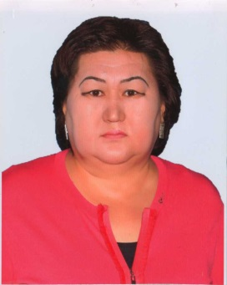 | Full name (according to the passport) | Кожабекова Ардак Жанкетаевна
 | date of birth | 24.04.1968
 | Gender( Female / Male) | Female
 | Nationality | Kazakh
 | Citizenship | Republic of Kazakhstan
 | Mobile number , Е-таil | 87025135377 ardak.1968.kz@mail.ru
Place of work: | KazNARU
Position: | Associate professor
Academic title: | candidate of Agricultural Sciences
education | High
experience: | 25
Foreign internship | -
Service activities (both inside and outside the institution): | 32 years
Scientific activity head and / or performer of research work in the Republic of Kazakhstan | themes of the performer
Scientific and methodological publications: | - Textbook "dendrology", Almaty, 2019. - 128 pages Shabalina M. V., Borisova Yu. s  - 2.”greening of the population". Training manual. Landscaping of settlements: - Almaty: IP "AI-tumar", 2019 . - 160 S. Toktasynova F. A., Abayeva K. T  - 3.” landscape design". Textbook. Publishing house "AI-tumar".- Almaty, 2019. - 188 P. Abayeva K. T., Shabalina M. V.
scientific publications: | 1."the current state, development, prospects and development of the dissertation article of the SCC of the Republic of Kazakhstan". Collection of materials of the international scientific and Practical Conference, 2019, 511 pages.  2.1 planting large seedlings of Schrenk spruce in the National Park of Le Alatau. article " international scientific and practical conference dedicated to the 20th anniversary of Ile-Alatausky GNPP 18-19 May 2016” Almaty, 2016-P. 18-21  3.effectiveness of shade trees in Desert and semi-desert zones for farm animals. article "international scientific and practical conference dedicated to the 20th anniversary of Ile-Alatausky GNPP" May 18-19, 2016  4.condition of the thorangi tree in the Southern Balkhash region. article"contribution of young scientists to the industrial and innovative development of the agro - industrial complex". "International scientific and Practical Conference of young scientists" 2019, 123 bstr  5.the nature of the torangi tree in the Southern Balkash region. article"contribution of young scientists to the industrial and innovative development of the agro - industrial complex". International scientific and Practical Conference of young scientists 2019, 123 P
Languages: | Russian, kazakh
family composition: | Full

